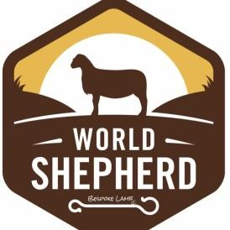
World Shepherd Project Lamb
Grass Fed --Pasture Raised ---Natural
Foodservice Price List *
Prime Parts (USDA inspected / Cryovac tray pack)
- Frenched Racks $15.65 / lb
- Loin chops $12.45 / lb
- Sirloin $11.00 / lb
- Boneless sirloin roast $14.00/lb
- Legs (bone in) $9.00 / lb
- Shanks $9.50/ lb
- Denver style Spare ribs $6.50/ lb
- Ground $8.50 /lb

*Prices are FOB Farmington GA
About World Shepherd Lamb
We grow a special breed of Hair-sheep or sheep who do not have wool. They are raised in Oconee County Georgia on several farms in the south end of the county. We are sustainable shepherds using no inorganic fertilizer, no feedlots, no antibiotics, and our lamb is raised in an extensive system where lambing occurs on pasture and forage rotations sustain them without using any human consumable grains for their growth.
Contact:
Greg Stewart
706.540.0833
Robin Stewart
706.296.0606
worldshepherd@gmail.com

